Reflections on the biblical and theological background to the Vision and Mission Priorities of the UPCSA

INTRODUCTION
After a process of wide consultation with Presbyteries, congregations, Church Associations and ecumenical partners through the work of the Assembly Priorities and Resources Committee, the 2012 General Assembly adopted a revised Vision, Mission and Values Statement for the UPCSA. We have since then been actively implementing this in Presbyteries and in congregations to a certain extent. We realize that congregations usually have their own areas of focus in ministry and in some places have formulated their own Vision and Mission Statements and Mission Priorities. Whilst we certainly encourage this we would also like to impress upon congregations the need to align what they do to that of the wider Church (UPCSA). This document is intended to achieve that purpose in which we attempt to offer information and scriptural validation for the vision, mission and values of the UPCSA. In each section we shall state what was approved by the General Assembly and then provide some additional notes and scriptural references where necessary.
Who is the Uniting Presbyterian Church in Southern Africa?
We are a diverse community of reformed Christians led by the Word of God and the Holy Spirit, prayerfully seeking the will of God for our lives together and the world.
There are certain key words in the above formulation of who we are as the UPCSA.
- “We are a diverse community of Reformed Christians….” We need to know our history and where we come from theologically. This is an important biblical principle. Also important is the fact that we come from different backgrounds, racial and cultural experiences, socio-economic settings and we use a variety of languages enhanced by our transnational richness. We believe that we are called to embrace our diversity as we seek to serve one another and the world around us and beyond in the love of Jesus Christ. This is what makes us to be a community.

- In addition we are a community of Reformed Christians attempting to remain faithful to the teachings we have received as we pass it on to the generations that follow (As Paul and Luke remind us in I Cor. 11:23 “What I received from the Lord, I passed on to you” Luke 1:1-3 Although others have compiled accounts of what had happened it appeared good to me (Luke) to likewise put together an orderly account of events…). Being Reformed could be summarized by the following 5 points:

Sola Scriptura: (Only scripture is to be our guide, not tradition)
Sola Fide: (By faith alone, we are not saved by good deeds etc.)
Sola Gratia (By grace alone, it is God’s generosity that sustains us)
Solus Christus: (Only through Christ, We have no other mediator or Saviour)
Soli Deo Gratia: (Glory only to God, The sovereignty of God is central)
- We recognize that we are not perfect as a church and that we continue to struggle to appropriate the ideals of the kingdom both among ourselves and in our witness to the world. Consequently, we rely on God’s Word and the Holy Spirit to lead us as we seek God’s will for our lives together and the world.

- We believe that it was the will of God to begin talks in 1994 which lead to union in 1999. John 17:21 Jesus’ prayer for Christians to be one so that the world would believe. Eph. 4: 11-13: He appointed Pastors and Teachers (ministers) to enable the body of Christ to grow in unity of faith. It is with this biblical call and vision that we continue to pursue the things of God (Phil. 3:12-14).

- UPCSA VISION, MISSION AND VALUES
Our Vision:
To be a reconciled community of Christians exercising a prophetic witness to Christ.
Notes:
Our vision recognizes our diversity as a Christian community and sets out the objective “to be a reconciled community of Christians.” We seek to be a “reconciled community” bearing in mind what the Apostle points out in II Cor. 5:19 “God was in Christ reconciling the world to Himself”. Reconciliation is a gift from God and we have the responsibility to pass it on: “He has entrusted to us the ministry of reconciliation”. We cannot pass on what we have not received and taken the responsibility for. This is further highlighted in John 17: 20-21 where Jesus prayed for the unity of believers. If reconciliation is not true for Christians, then they have no message to proclaim to others.
Our unity also strengthens and gives credibility to our Prophetic witness as we proclaim God’s sovereignty over the world. There is so much of evil, sin and injustice in the world that we cannot afford to remain silent or complicit. As Christians we are called to be “Witnesses” (Acts 1:8) “You will be witnesses of me in Jerusalem….to the ends of the earth” and Acts 22:15 “Witnesses of what you have seen and heard.” We cannot speak to others concerning things we do not know. Christ must be a living reality to us so that we can be a credible witness of what we have seen and heard.
Our Mission:
We will proclaim our Triune God in Southern Africa through:
- Bearing witness to the saving love of Jesus Christ
- Building vital, reforming congregations for worship, ministry and discipleship
- Visibly proclaiming the Kingdom of God through unity, justice, peace and love.

Notes:
The Mission is to proclaim our Triune God in Southern Africa…
Proclamation is an important aspect of the Gospel message. Ps 92:15 “Proclaim – the Lord is upright…”. Mark 1:14 “Proclaiming the Good News…”; Luke 8:1 “Proclaim the Good News of the Kingdom of God..” Acts 5:42 “Proclaim Jesus is Lord…” Acts 17:3 “This Jesus I am proclaiming.” Proclamation is closely linked to “speaking boldly”: Acts 4:29 & 28:31.
Triune God: See structure of the Apostles’ Creed. See especially the Confession of Faith, Chap. 5: Trinity
“Bearing witness to the saving love of Jesus Christ.” It is important to know why we need a Saviour. Save us from what? See Isaiah 6:5; Rom 3:23; See also UPCSA Confession of Faith, Manual Chap.2 Par. I “The Need for Redemption”
“Building vital, reforming congregations”: Know our spiritual heritage and what the Presbyterian Church’s specific points of belief are. See Document “Fundamentals Points of Doctrine”
FUNDAMENTAL POINTS OF DOCTRINE
- There is only one true and living God.
- God’s self-disclosure in Jesus Christ and in the outpouring of the Holy Spirit reveals the triune nature of one God existing in three eternally distinct but indivisible ways of being: the Father, the Son and the Holy Spirit.
- God created all the universe and created it very good.
- Yet all human beings, however real their virtues, are trapped in a state of sin and guilt, unable to rescue themselves or put themselves right with God.
- God in holy love and grace has acted in Jesus Christ (through his incarnation, ministry, life, teaching, death, bodily resurrection and exaltation) to atone for our sins, rescue us from judgement, reconcile us with God and reveal God’s nature and will to us.
- As both fully divine and fully human, Christ is the only Mediator between God and humankind, their only Saviour and the decisive revelation of God as God is.
- The Holy Spirit working within us convicts us of sin and enables us to accept God’s saving and sustaining grace in Christ by faith and to live according to God’s holy will.
- The Word of God in Scripture, preaching, personal witness and the Sacraments conveys the gospel to us and so is the means by which God saves us through faith in Christ.
- We are put right with God only by God’s grace in Jesus Christ, when we receive Christ as Lord and Saviour, which we do through faith alone.
- True faith involves obedience to Christ as Lord and Saviour: ‘only the person who believes is obedient, and only the person who is obedient believes’.
- As Christ is Lord over every area of life, this obedience means to obey his will in both the private and the public areas.
- In Christ there is no ground for separation or discrimination between people on grounds of race, colour, social status or gender, either in Church or in State.
- The gospel calls us to worship regularly with God’s people, to meditate on Scripture and to be diligent in prayer.
- God demands strict chastity outside marriage and exclusive faithfulness in marriage.
- God calls the Church to be a Church for others: a missionary Church reaching out to the world with the gospel and a serving Church seeking to serve society and aiding the poor.
- God calls the Church to serve as a sentinel vis-à-vis the State, calling the Government to order for unjust policies and practice.
- We are to use our own money not only to care for ourselves and our families but to aid the poor and support the Church.
- We are to care about, and care for, the environment.
- God does not stand aloof from us but cares for us all and is present with us in all our tragedies and our joys.
- A day is appointed when God will come in the person of our Lord and Saviour Jesus Christ to judge the living and the dead and will finally triumph in victory over all evil, sin, oppression, suffering and death itself.

“Visibly proclaiming the Kingdom of God through unity, justice, peace and love.” The present evidence of God’s reign (God’s Kingdom) needs to be pointed out to people. Luke 10:11 “Be sure of this, that the Kingdom of God is near you.” The effect of evil has a binding (tying up) effect as well as a blinding effect. Jesus’ inaugural sermon (Luke 4:18 -19) emphasised the setting free of those that are bound as well as restoring sight to those that do not see. (See Luke 13:16).

“Proclaiming Justice” requires the identification and loosening of institutionalized structures that “bind” & “blind” people. See Confession of Faith Par. 25 “The World in which Redemption Takes Place”.

Our Values
Together we have ascertained the following values to guide our behaviour to each other and the world.
- Love (Prov. 10:12,17:17, Rom 12:9, 13:10, 1 Cor. 13:4-13, Col. 3:14, 1John 3;16-18, 4:8, John
3:16, Matt. 22: 37-39).
- Holiness (Isaiah 35:8, Leviticus 20:26, 19:2, 2Cor. 7;1, 1 Peter 2:5-9, 1Thess. 4:4-7, Heb. 12:14, Rom. 12:1, Philippians 4:8, Col. 1:22).
- Scriptural (Isa. 40:8, Prov. 30:5, Deut. 4:2, Ps. 119:105, Jeremiah 23:29, Hebrews 4:12, Eph. 6:17,
Rom. 10:17, 1John 1:1-2, Rev. 12:11).
- Integrity ( 1Kings 9:4-5, Ps. 41:11-13, 26:8-12, 25:19-21, Prov. 2;6-8, 20-21, Job 2:3, 1Tim. 2:1-4,
Titus 2:7-8, 1Peter 3:10-12, Luke 16:10, Col. 3:9-10, Philippians 4:8)
- Spiritual Growth (Jeremiah 1:5, 1 Peter 2:2-3, 2Peter 3:17-18, Phil 1;6, 3:12-15, 1Cor 13:11, Heb.
6:1-2 Eph. 4:13-15, 20-24. 1John 2:1-11)
- Servanthood (2 Kings 5:1-27, Ps. 110:1, John 12:25-26, 13;16, Gal. 5:13, 6:9-11, Phil. 2:5-7, 17,
Eph. 5:21, Luke 12:45-47, 22:27, Mark 10: 42-45, 1 Peter 4:10-11, Rom. 12:9-13).

THE UPCSA MISSION STRATEGY
In order to implement the Vision, Mission and Values of the UPCSA the 2012 General Assembly approved the following Mission Priorities in the UPCSA.
- Evangelism
- Supporting the development of missional congregations.
- Health, wellbeing and securing justice.
- Engaging in reconciliation and unity:
- Stewardship

Although we have established five (5) mission priorities for the UPCSA, the overarching and central significance is the supporting and development of missional congregations. We recognise that mission really happens through local congregations and as a new strategy for the UPCSA we are seeking to equip, enable and empower the local church for mission. We believe that in investing in the local church we are better placed to engage God’s mission in the world. Hence all our mission priorities are interconnected and intended to build the local church for mission as indicated in the diagram below.

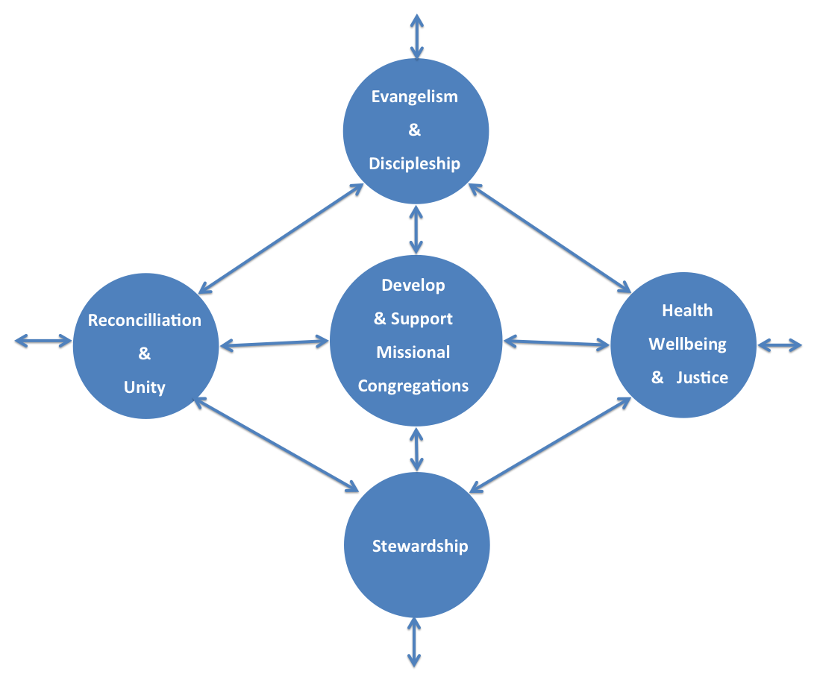

Notes on the UPCSA Mission Priorities

Evangelism
The core purpose of the church is to proclaim the good news of life in Jesus Christ. We proclaim the sovereign reign of God who has given us the gift of salvation purely by grace and not by any merit or work we have done (Rom. 10: 11-15, John 3: 16-17, John 14: 6, John 10: 16). We are thus tasked to go out as believers to be witnesses (Act 1: 8) to Jesus Christ as we make disciples, teach, and baptize ( Matt. 28: 16-20). We do this in both Word and deeds as we rely on the Holy Spirit to change hearts and lives to embrace the character and values of Jesus in creating a better life for all. We recognise that changing hearts is not enough since following the example of Jesus we are called to transform the community in which people live (Luke 10: 25-37). We understand Christian mission to be a wide and inclusive complex of activities aimed at the realisation of the reign of God in history. It includes evangelism but is at the same time much wider than that. Perhaps one could say that mission is the 'cutting edge' of the Christian movement - that activist streak in the church's life that refuses to accept the world as it is and keeps on trying to change it, prodding it on towards God's final reign of justice and peace. We thus accept that evangelism can involve many and varied activities but the chief aim is to bring people into a relationship with the Lord Jesus Christ and with His Church. The priority is to identify and respond to the many ways in which the Good News is currently being proclaimed to those who do not now believe (Rom. 3:23; 1 Cor. 1:18).
The Assembly Mission and Discipleship Committee have been tasked to oversee the above Mission Priority with the following objectives:
- To Inspire the UPCSA to think in terms of growth and mission.
- To Mobilise members of the UPCSA for mission – lay people and clergy.
- To Resource endeavours aimed at Mission and Evangelism.
- To Invest money in the growth of the UPCSA.
- To Reach unchurched communities and the ‘mission field’ for Christ.

Health, Wellbeing and Securing Justice

The UPCSA recognises that it has a prophetic and solidarity role to play as it addresses injustices and evil systems in the world and takes up the challenges of the disadvantaged and poor. We commit ourselves to work towards the ‘fullness of life’ for all by addressing issues of health, wellbeing and securing justice, which we believe is a biblical call as we seek the transformation of both individuals and society (For examples see: Isaiah 1:17, 58: 6-12, Jeremiah 22:3, Micah 6:8, Amos 5:11-15, Prov. 31:9, 1John 3:17-18, James 1:27, Luke 4:18-19.) We acknowledge that this role is required both within the church and society at large. Our task is to raise these matters within the UPCSA whilst at the same time dealing with injustices in our countries and communities.

We realize that health and wellbeing is often affected by injustices, oppression and abuse. We have therefore combined all of these to offer a holistic approach to addressing injustices in our society (John 10:10). For example, we have previously worked on HIV and AIDS on its own but now we have placed it in this category because we recognise that responding to the AIDS pandemic requires addressing matters of poverty, nutrition, economics, socio- political issues and not just lifestyles and medical intervention.
The Assembly Church and Society Committee has been tasked to oversee the above Mission Priority with the following objectives:

To engage and mobilise congregations on Church and Society issues
- To help our Church to reflect, dialogue and act on issues of health, wellbeing and justice
- To assist in providing quality education and care for children through our Schools and Clinics.
Engaging in Reconciliation and Unity
The Bible calls us to make and live in peace, to forgive others and seek forgiveness, to work for reconciliation, unity and healing (Gen. 32:1-24; Isa. 61:1-4; Matt. 18: 15-17, 5: 23-26; Eph. 4:32; 2Cor. 5:18-22; Rom. 5:10; Col. 1:20-22; Luke 6:27-42).The UPCSA is a diverse family consisting of different cultures, races, languages and economic backgrounds. This diversity can be both a strength and challenge as we seek to embrace one another in the work of God wherever we are. Reconciliation and unity offers particular challenges to the UPCSA at this time in two specific areas: (1) in providing a visible witness to the possibility of further healing the divisions that colonialism, neo colonialism and apartheid have created and, (2) enabling the church associations to get to a place of greater unity (Eph. 4: 1-6, 2:11-22, 1John 2:1-14). We see reconciliation and unity as a wider focus in our countries and in the life and work of churches in general. Further, the UPCSA is committed to work toward the unity of Christian churches and is pleased that some of our leaders are involved in this in the ecumenical engagements in respective countries and world-wide (John 17:6-26).
The Assembly Church and Society Committee is tasked with the above Mission Priority with the following objectives:
- To help our Church reflect theologically in engaging and acting on issues of reconciliation and unity.
- To address issues of reconciliation, healing and unity both within the UPCSA and outside of our church.
- To foster reconciliation and unity through practical engagements in both church and society.

Stewardship
The Bible tells us much about stewardship which is generally seen to include the giving of one’s time (1 Tim. 1:17; 2Peter 3:8; 1 Sam. 9:16; 2 Chron. 24:11), talent (Matt. 25:14-30, Luke 19:11-26) and treasure (Malachi 3:8-12, 2 Cor. 8:1-15) to God’s service and the understanding that God alone gives the increase (Eph. 4:7-13). The God who gave all for us expects us to give ourselves for Him and ‘stewardship’ is the facilitating of this giving of ourselves. It also impresses upon us the biblical call to be good stewards as we covenant for justice and the care of the earth (Ps. 24:1; 103:19-22, 19:1-6) which also requires that we share our resources and empower the poor (1 Tim 6:17-19, Acts 2:44-45, James 2: 14-19.)
Stewardship is a key dimension of the programme of renewal of the UPCSA community through its mission priorities. In this manner the goal of the Stewardship programme at the level of the denomination is to contribute to renewal and the establishment of a giving, sharing, caring, just, reconciling and uniting community of the UPCSA in which all resources are managed equitably to the glory of God and in celebration of our diversity.
The Assembly Stewardship Committee is tasked with the above Mission Priority with the following objectives:
- To advocate for equitable sharing of resources
- To prepare and develop church leadership and stewards to be able to handle stewardship programs (leadership development). Leadership development remains a glaring need if we are to attain our vision.
- To empower, support and strengthen congregations for growth and sustainable ministry.
- To create more awareness on issues such as ecology, environment and climate change.
Conclusion
In this document we have attempted to give you more details, biblically grounded, regarding the current Vision, Mission, Values and Mission Priorities of the UPCSA. If these are to become a reality within our denomination then it is expected that Presbyteries and, in particular, congregations will need to embrace these and implement them within their local context and community. Our prayer is that you would do just that. The respective Assembly Committees, as mentioned in the document, have already set, and are currently implementing “action plans” to achieve their set objectives. Please do not hesitate to be in touch with any of them for further information and/or assistance to help you to be a part of what God is already doing amongst us within the UPCSA.

